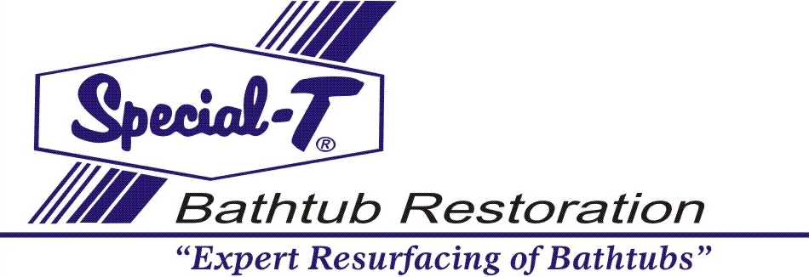

You can be proud you have chosen Special-T Bathtub Restoration, the finest resurfacing material on the market today. With proper care and maintenance your beautiful new finish will last for many years to come.

For five (5) years after the installation of your Special-T bathtub Restoration surface, should the product or workmanship prove faulty, the Special-T bathtub restoration dealer who performed the work, will upon notice from you because such faults to be corrected at no additional cost.
Special-T Bathtub Restoration
690 Beaconsfield road
Nanaimo B.C. V9R1X2
250-668-9414

DATE...........................................
NAME................................................................................................................
ADDRESS.............................................................................................................
CITY.......................................................................................................................

